**SUSTAINABLE OUTREACH AND UNIVERSAL LEADERSHIP LIMITED   
(SOUL)**



**PROJECT EDULEAD**



**Hostel Module User M****anual**

**VERSION HISTORY**

| **Date** | **Version No.** | **Created By** | **Updated Section** | **Updated By** |
| --- | --- | --- | --- | --- |
| 15-09-2022 | Version 0.1 | Rupali Bhatta |  |  |
|  |  |  |  |  |

**Introduction:**

The user manual is designed to provide relevant, and content specific information for the user to use the Hostel module of the Polytechnic application in the Edulead product.

**Purpose and Scope:**

The purpose of the document is to provide step-by-step guidance to users for Hostel module function work.

**Edulead Users**

The system shall be available to and accessible by Education Administrator, Accounts Officer, Accounts User, Instructor and Student of the organization

**Login**

Edulead Users will navigate to the URL and enter their credential in the screen as shown below

**URL** - *https://testkp.eduleadonline.com/#login*

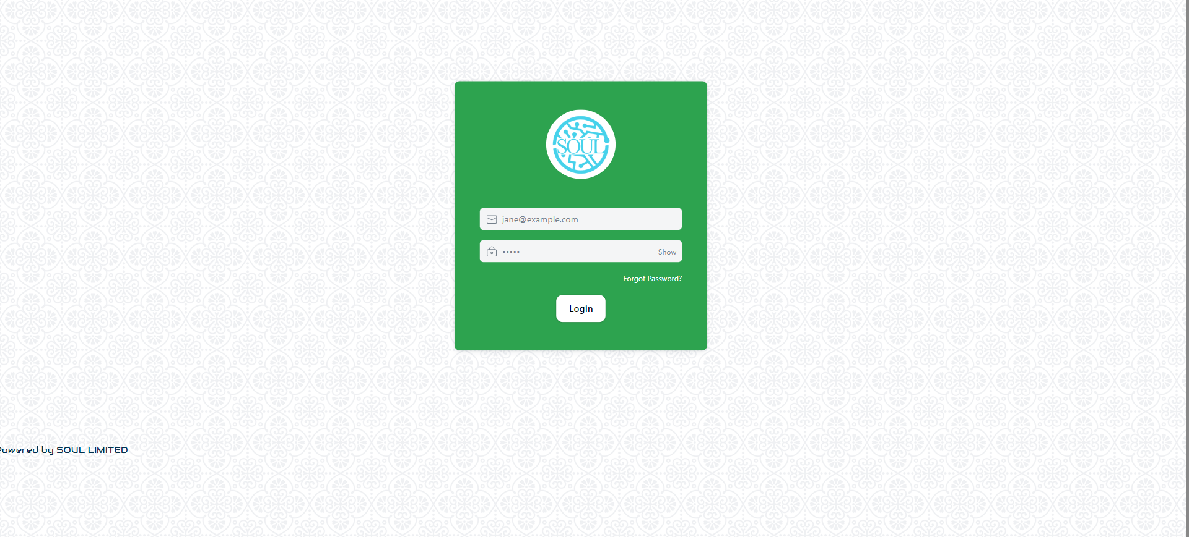

**Login with Email-ID**

Edulead Users can login to the screen with their Email-ID and their password.

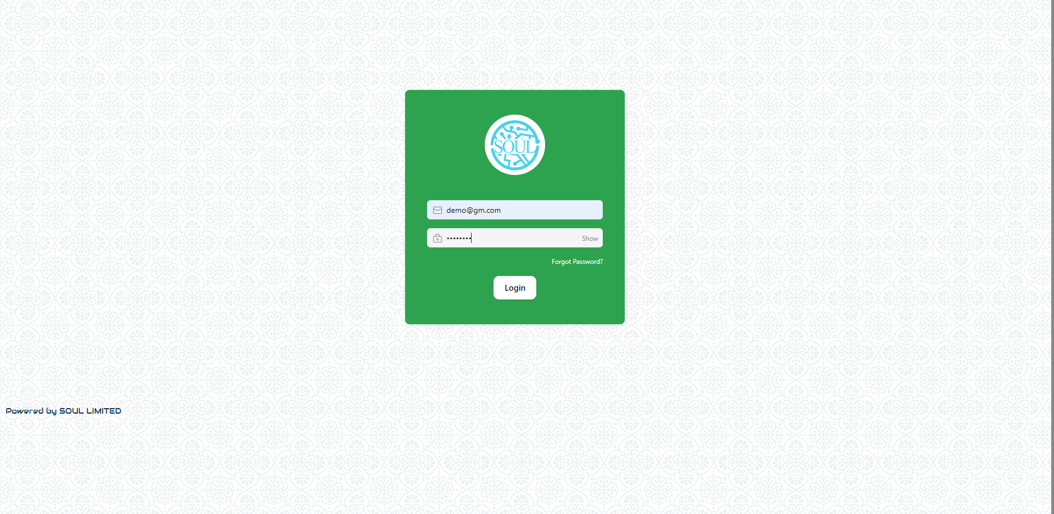

**Masters Modules:**

**Hostel Masters-**

To access Department, go to: Home > Hostel-HOD> Masters > Hostel Masters

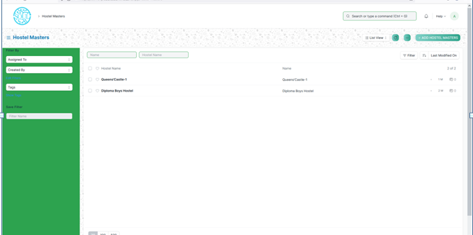

To add new Hostel, user has to click on Add Hostel Masters button. Then it will open the below screen. There are two search fields viz Name and Hostel Name. User can search for the hostel by filling any of the value.

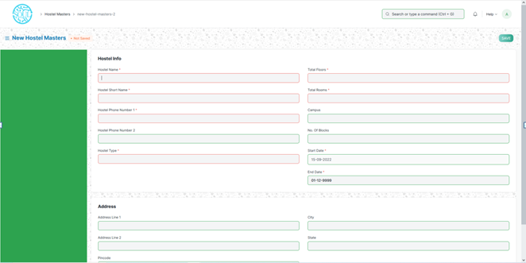

The red colored star is denoted as mandatory field. So user has to fill all the mandatory fields.

User should enter a Hostel Name, Hostel Short Name, Phone No., Hostel Type, Total floors, Total rooms, start date and end date. Hostel address also to be filled.

After filling the above screen, user has to click on save button. It gives the user to update anything related to the hostel later. Once updated again need to save the form.

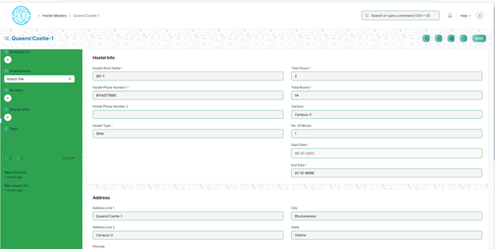

**Room Master-**

This screen will show the details of rooms for a particular hostel. To add room master data user has to click on Add Room Master.

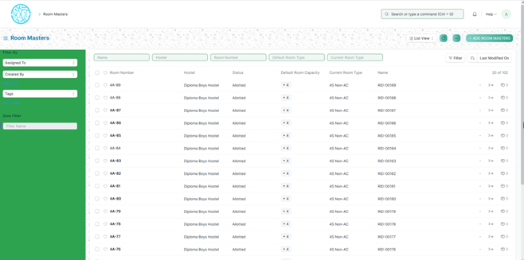

Then below screen will be shown.

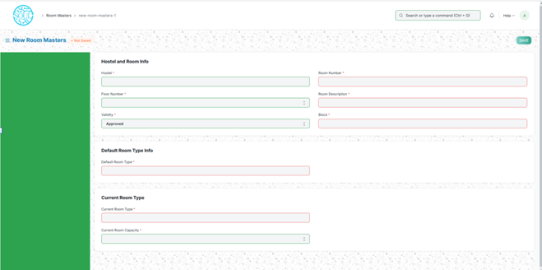

User has to fill all the mandatory fields. Then save the form. It’s an updatable form.

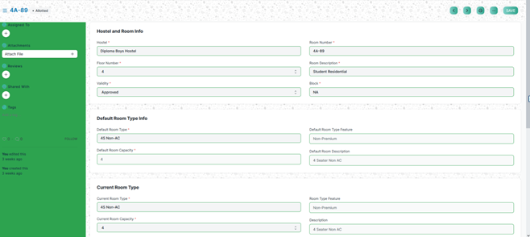

**Hostel Type-**

In this screen user can define Hostel type. It can be for boys and girls. User has to click on Add Hostel Type.

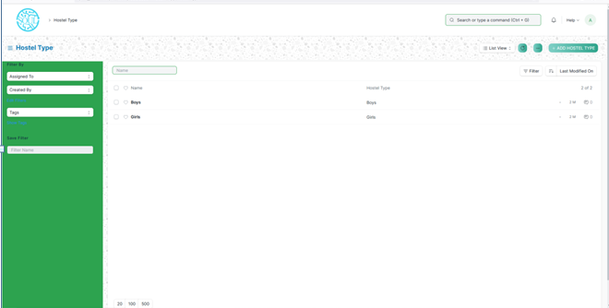

**Room Type-**

In this screen user can define room type. To add new room type , user has to click on Add room Type button.

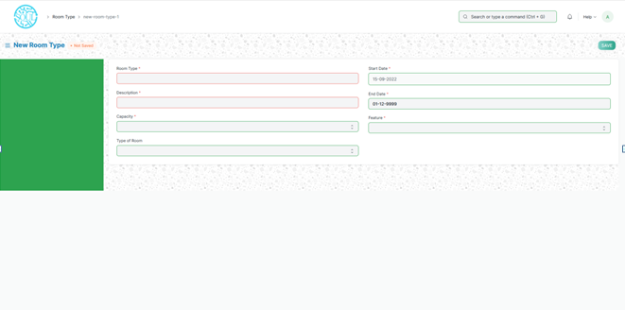

After filling all the required fields, click on save. It is also a updatable form.

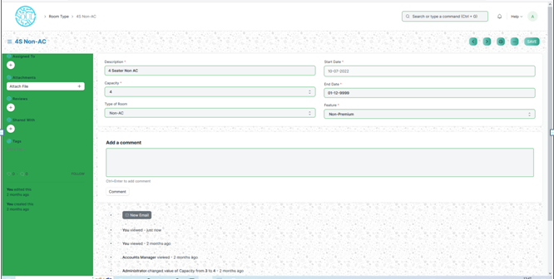

**Room Description-**

This form contains the description of the rooms. To add new room description user needs to click on Add room description.

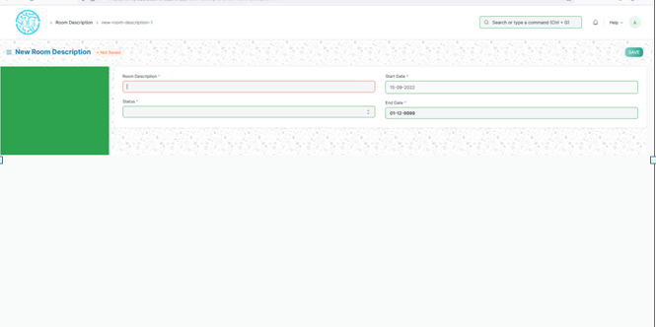

Fill all the required fields and click on Save.

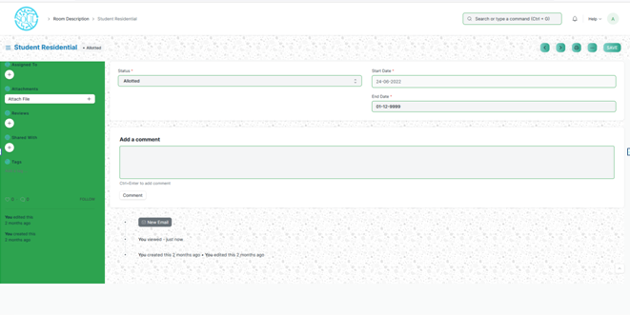

**Employee Hostel Allotment-**

This form is for the employee who will be allotted to the hostel. To create new, click on Add Employee Hostel Allotment.

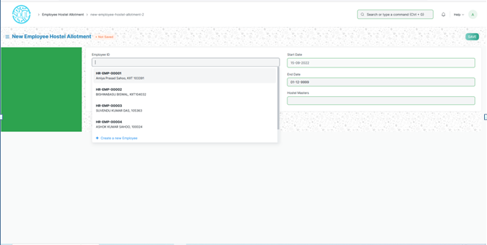

Enter the Employee Id from the list and all other required fields. Then click on save.

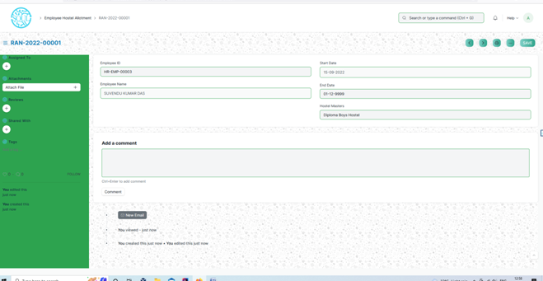

**Student Hostel Admission-**

**Prerequisites-**

* **Student**
* **Hostel**
* **Room Type**

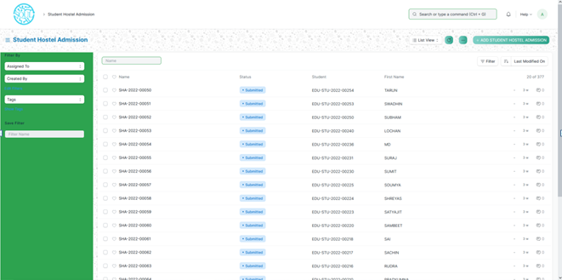

This form is for the student who can be allotted to a hostel. To add new student click on Add student Hostel Admission. It will open the below screen.

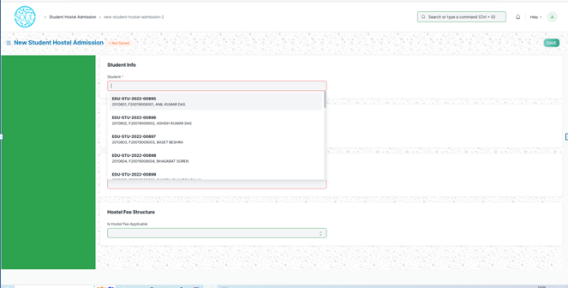

Fill the form with all the required data. And click on save and submit. It’s a submit able form.

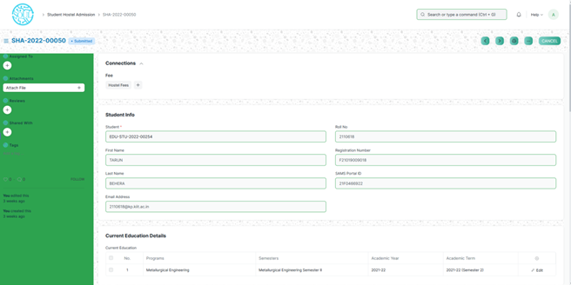

**Student Medical History-**

In this form student has to enter the medical related information if she/he has.

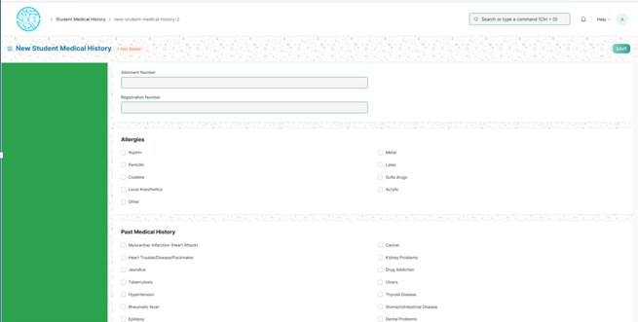

It is an updatable form. Once enter the data user has to save it. She/he can modify later also.

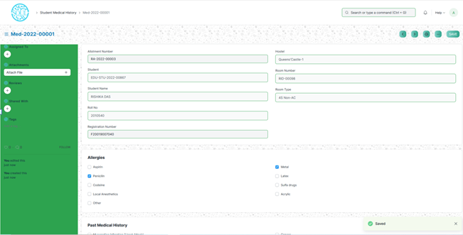

**Student Leave Process –**

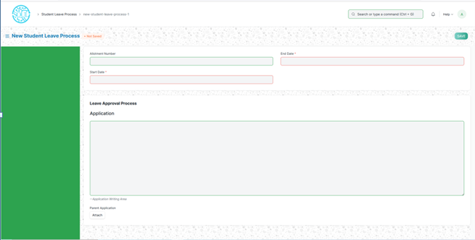

In this form if student wants leave then she/he has to apply for leave for the hostel also. User has to fill all the required information. Leave details like start date and end date. Parent’s application can be attached.

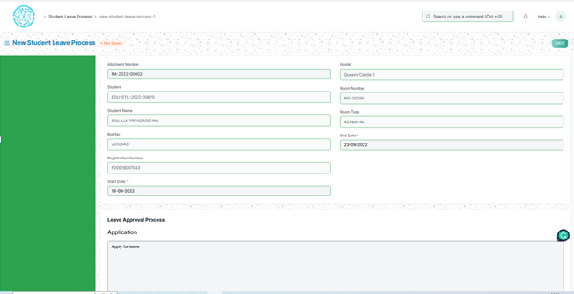

After filling the form user has to save the form.

**Material Distribution-**

**Prerequisite**: Before filling this form user should have below information

* Hostel
* Room Number
* Room Type
* Allotment Number

In this form user has to manage the material distribution against the candidate. He has to select one student then all the student details will be auto fetched. Then there will be some checkbox for the materials. User has to select the materials. And then save the form.

**Room Allotment-**

**Prerequisite**: Before filling this form user should have below information

* Student
* Room Number
* Room Type
* Allotment Number

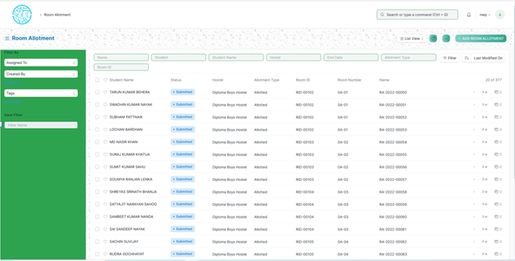

In this form the student allotted to which room details can be found. To add new room allotment click on Add Room Allotment.

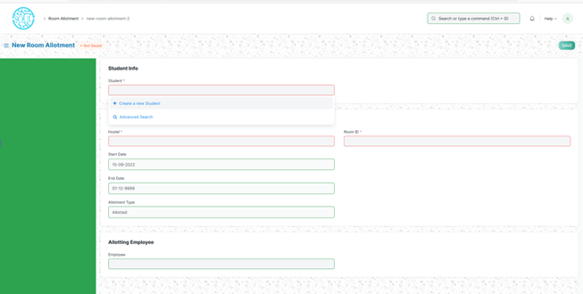

Here user needs to select a student. Then all the details related to that student will auto filled. Then in the allotment details Hostel details need to be filled. Guardian Information also needs to be filled. After that click on save and submit. The form will look like this.

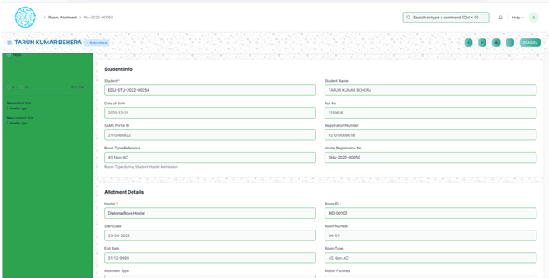

**Room De-Allotment-**

**Prerequisite**:

* Student
* Allotment Number

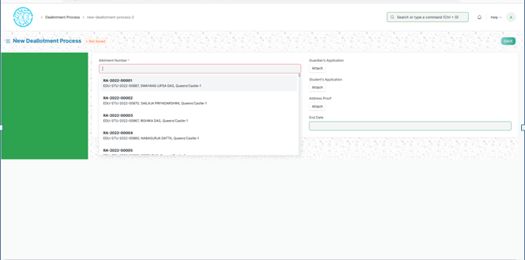

It is the room de-allotment process. To add new de-allotment process click on Add de-allotment process. User needs to select the allotment number then the related data belong to that student will be auto fetched. User can attached guardian’s application, student’s application and address proof.

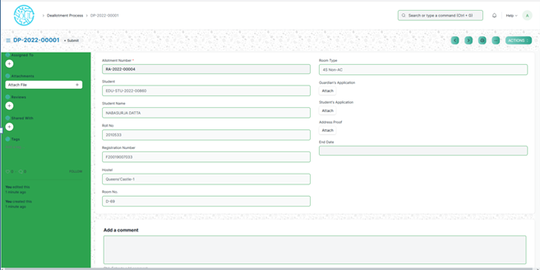

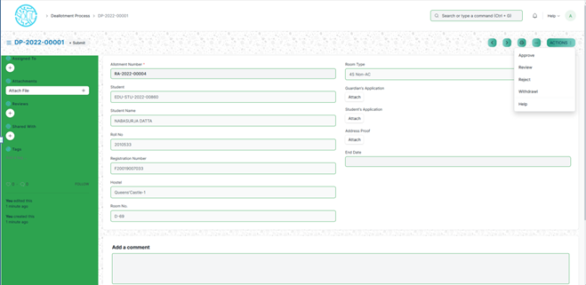

In the action section user can choose any of the option for further process.

**Room change-**

**Prerequisite**:

* Student
* Hostel
* Room

If the student wants to change the room he/she can apply. For that user needs to click on Add room change.

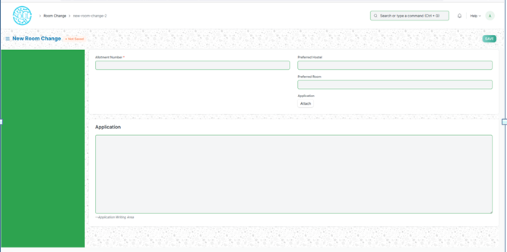

Select the allotment Number from the list. Then user can select preferred Hostel and preferred room. Then click on save. Then this form will go for some actions like Review, approve, withdrawal.

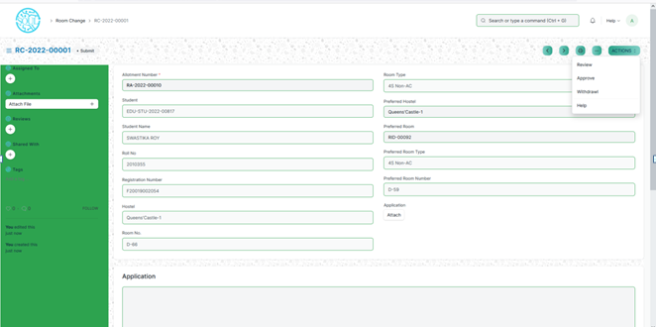

**Death De-allotment-**

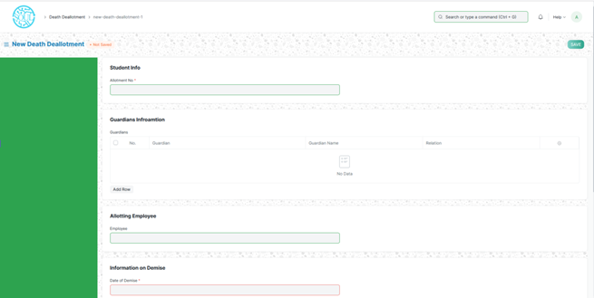

To add new death de-allotment click on add death–deallotment. Select the allotment no. and filled the mandatory fields. And click on save and submit.

**Long Leave-**

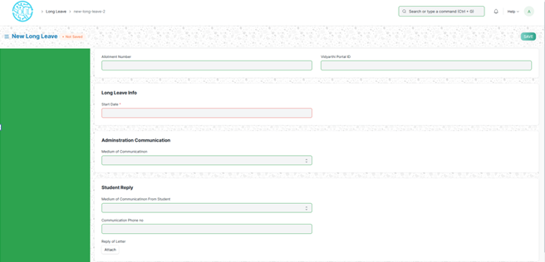

Select the allotment number and the long leave info i.e. start date. Also fill the administration communication and Student communication details. Click on save and submit. Then it will be notified to administration dept.

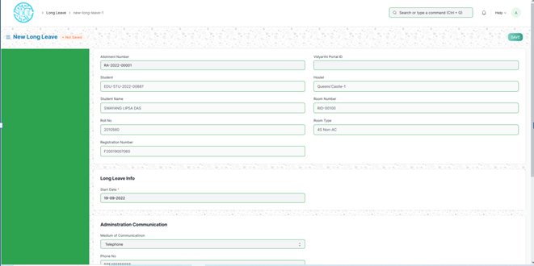

**Inter or Intra Hostel Change –**

To add new inter or intra hostel change click on add inter or intra hostel change button. It will load below screen.

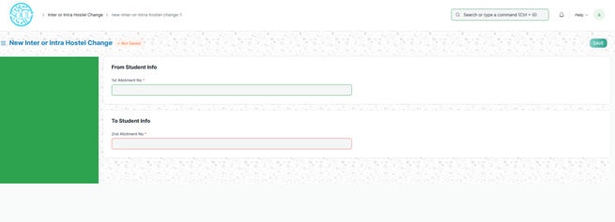

User has to select the from student and to student info.

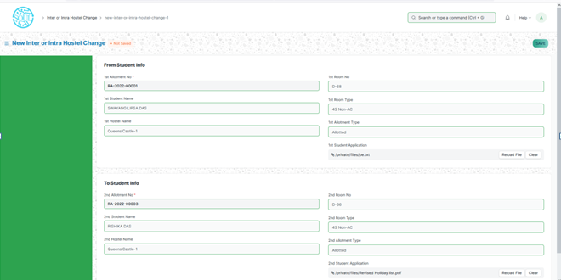

Click on save. It’s an updatable form.

**Hostel Clearance-**

To create new hostel clearance click on Add hostel clearance.

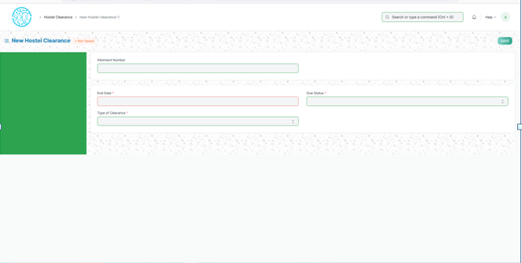

Select the allotment Number. The student details will be auto fetched. Fill the mandatory fields like end date type of clearance and due status.

If due status is dues then user has to enter the dues amount and the reason for the dues.

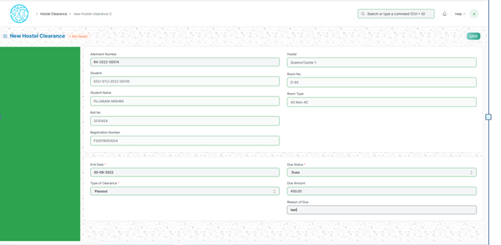

Then click on save and submit the form.

**Hostel Attendance-**

To add hostel attendance click on Add hostel attendance.

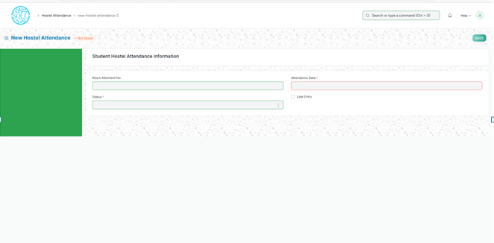

Then select the room allotment no., attendance date and status. Then click on save and submit.

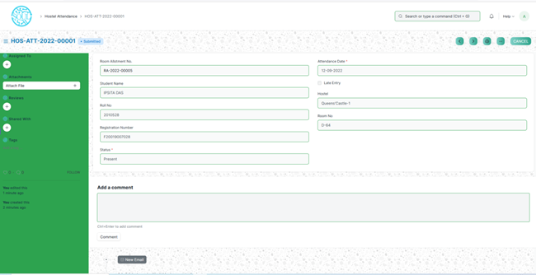

**Hostel Attendance Tool-**

It’s a tool where user can make the student attendance in bulk. User has to select the hostel and room. Then select the student and click on Mark Present or mark absent.

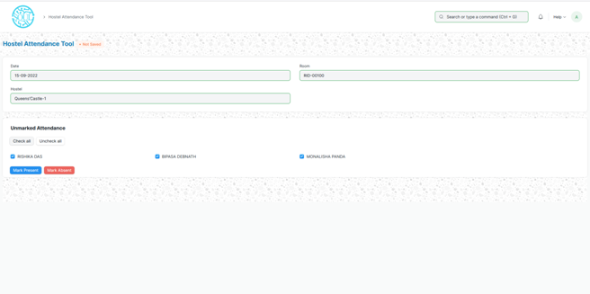

**In disciplinary Complaint Registration-**

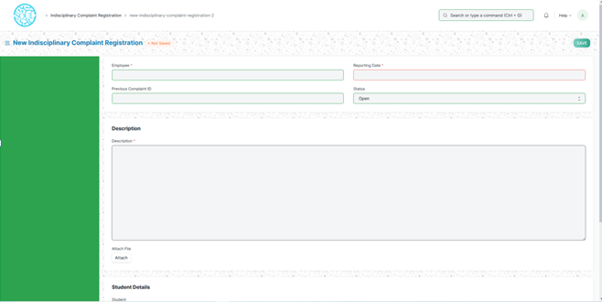

User needs to select employee, reporting date and description (mandatory fields). And also the students details who raise the complaint against the employee. Click the save button. It is an updatable form.

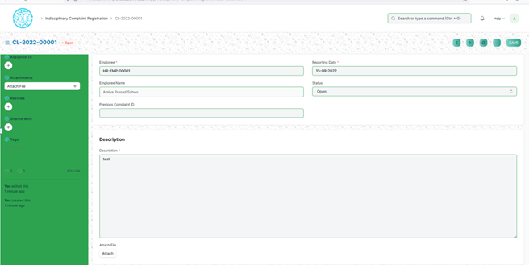

**In disciplinary Actions-**

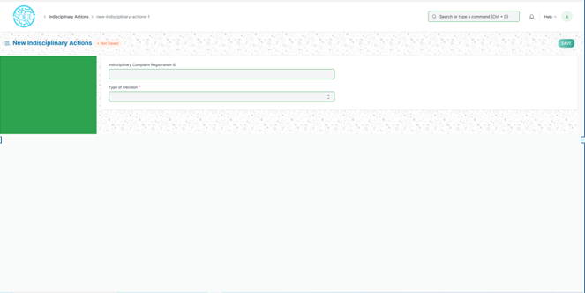

In this form user has to select the In-disciplinary complaint registration id and type of decision. Then click on save.

There are 4 types of decisions.

If user select from Type Of Decision ->Fine Letter below screen will load. Here user will enter the Fine letter related details.

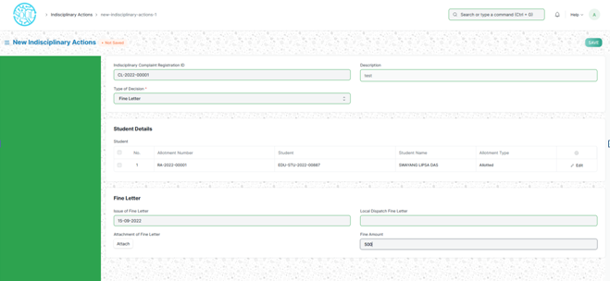

If user select from Type Of Decision -> Warning letter. The screen will look like as below.

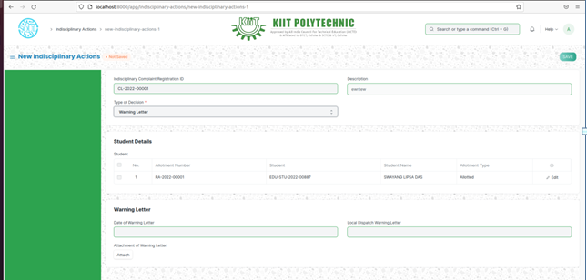

If user select Type Of Decision -> Suspension letter. The screen will look like as below.

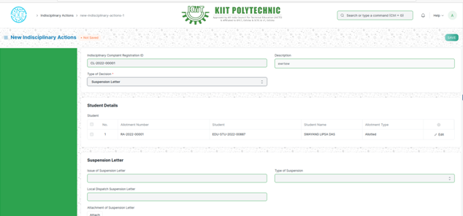

If user select Type Of Decision -> Disciplinary Committee. The screen will look like as below.

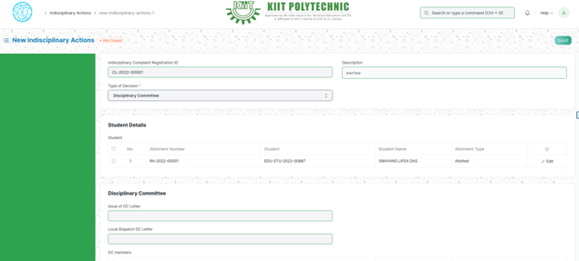

If user select Type Of Decision -> Debar letter. The screen will look like as below.

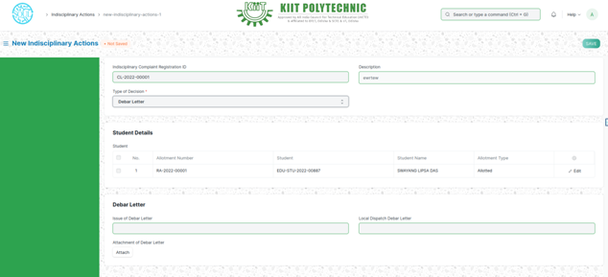

If user select Type Of Decision -> Parents Call letter. The screen will look like as below.

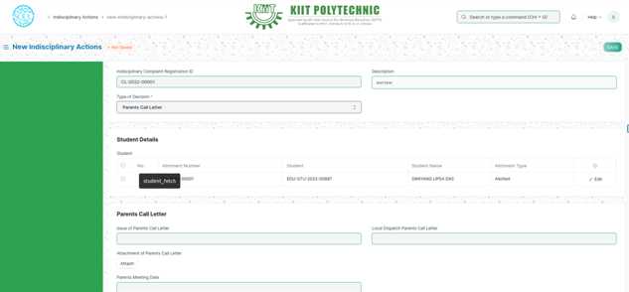

**Disciplinary Committee Meeting-**

**Prerequisites:**

### Add In-disciplinary Actions and Type of Decision will be **Disciplinary Committee**.

To add new Disciplinary Committee Meeting click on Add Disciplinary Committee Meeting button. Then below screen will load.

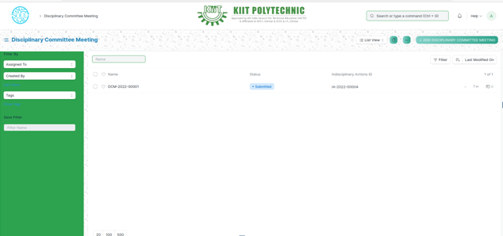

Here user needs to select one In-disciplinary Actions Id. On the basis of Id , DC Member and Student details will load. Fill all the mandatory fields and click on save and then submit the form.

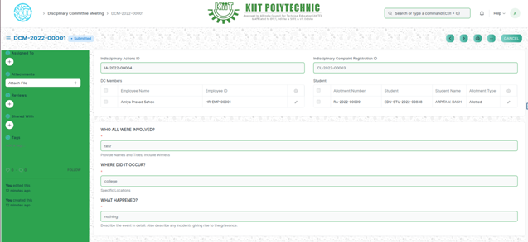

**Withdrawal of Suspension-**

**Prerequisites:**

### Add In-disciplinary Actions and Type of Decision will be **Suspension Letter**.

### Type of Suspension – Hostel suspension

To add new withdrawals of suspension click on add withdrawal of suspension button. Below screen will load.

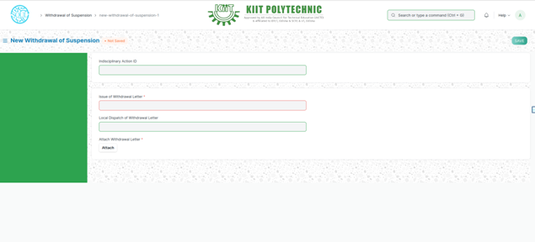

User needs to select the In-disciplinary action Id respect to suspension letter. Then all related info will auto populated. Then user needs to fill the mandatory fields. Click on save and submit button.

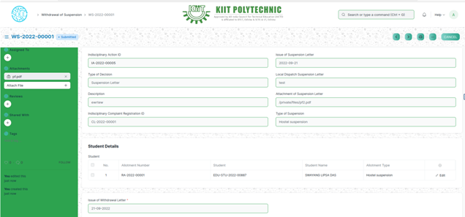

**Hostel Suspension Room Change-**

**Prerequisites:**

### Add In-disciplinary Actions and Type of Decision will be **Suspension Letter**.

### Type of Suspension – Hostel suspension

To add hostel suspension room change user needs to click on add Hostel suspension room change.

Then user will enter the allotment number respect to hostel suspension. Then all the related information will auto populated.

User need to enter the In-disciplinary action Id with respect to suspension letter.

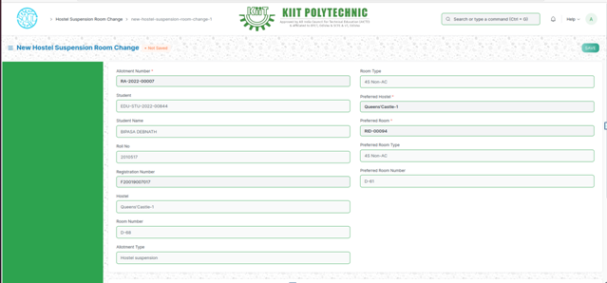

**Inward Suspension Letter-**

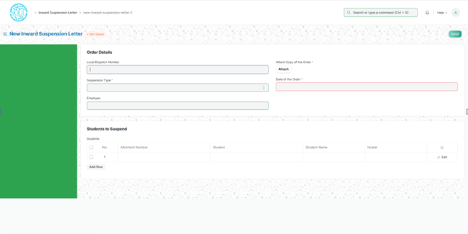

Enter the mandatory fields like suspension type, attach copy of the order and date of order. Fill the employee and the students to suspend.

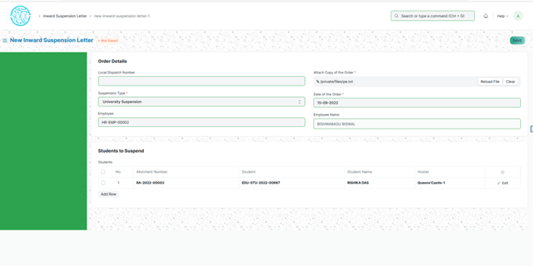

Then click on save and submit.

**Withdrawal of Inward Suspension Letter-**

Click on Add withdrawal of Inward Suspension Letter button, it will load below screen.

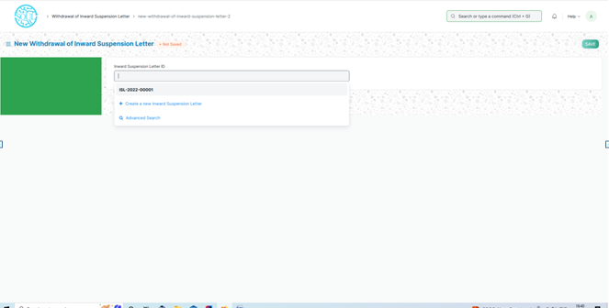

Select the inward suspension letter id from the list.

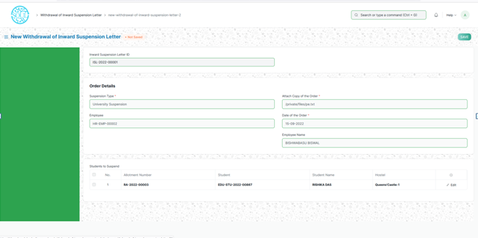

Click on save and submit.

**Fee Structure Hostel-**

**Prerequisite**:

* Programs
* Semester
* Fee Type
* Room Type
* Academic Year
* Academic Term
* Fees Category
* Receivable Account
* Income Account

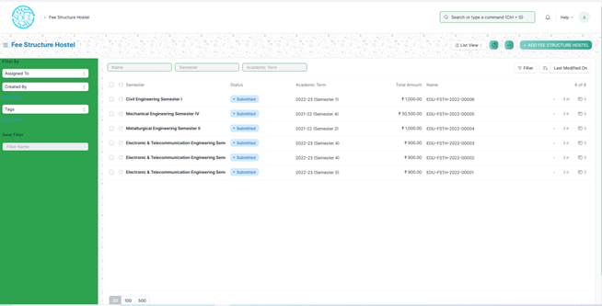

In this form fee structure will be created for hostel of different branches. To create fee structure click on add fee structure hostel. It will load the below screen.

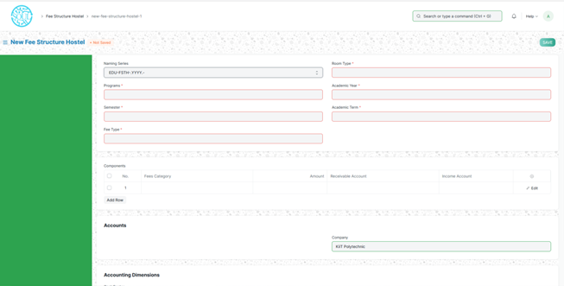

Fill all the mandatory fields. After filling, the form will look like below screen.

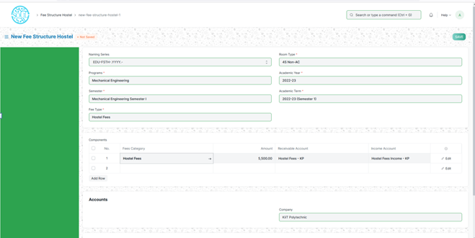

Then click on save and submit the form.

**Hostel Fee Schedule-**

**Prerequisite**:

* Fee Structure

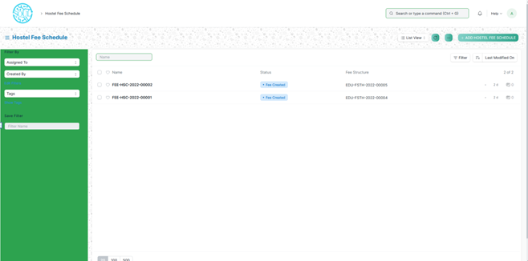

To add hostel fee schedule click on button Add hostel fee schedule. Below form will load.

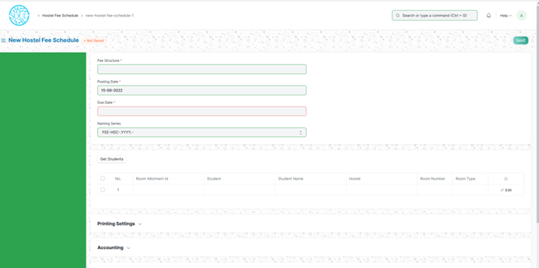

Enter the mandatory fields. Click on get student button, it will fetch the students match to the filled data.

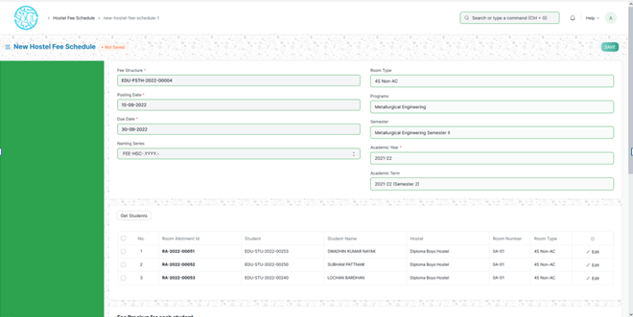

Then click on save and submit button. So it will be in Fee creation pending status.

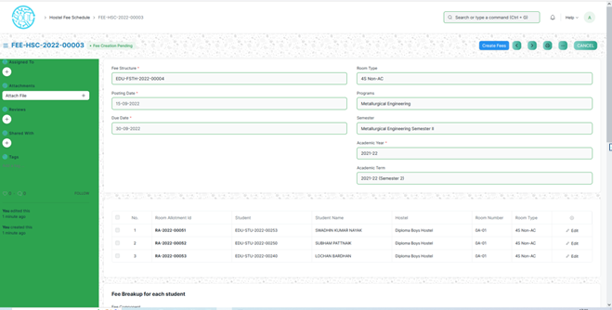

To be fee created click on Create Fee button on the top of the form. Once fee is created, the screen will look like as below.

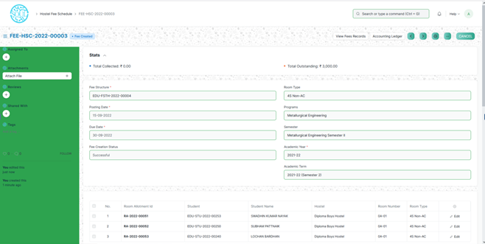

**Hostel Fees-**

**Prerequisite**:

* Student
* Hostel Fee Structure
* Fees Category
* Income Account
* Receivable Account

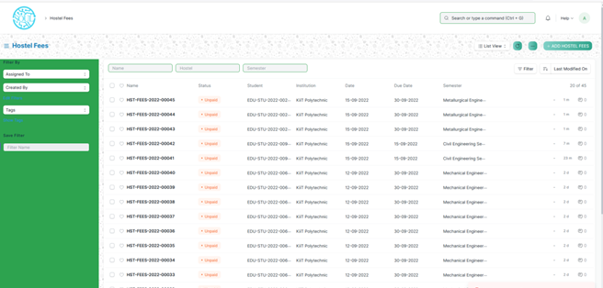

To add new hostel fees, click on add hostel fees button. It will load below page.

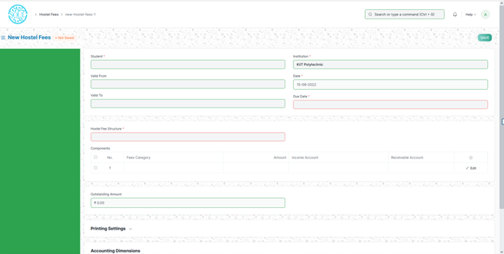

Hostel fees will be calculated against the student. So select the student and student details will be auto populated. Then enter the Hostel fee structure. Then screen will look like below.

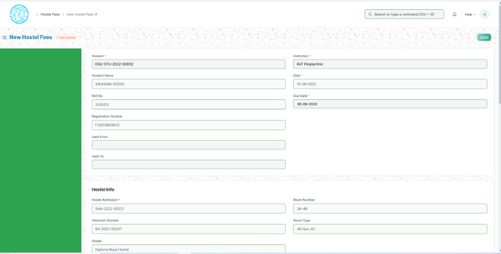

Then click on save and submit.